Programming Assignment

Lesson 7

CISC 071

By

<Jeremy Reuwer>

Date: <03/14/2019>

Purpose

* To learn about “if” statements

Rubric

* Correctness: 2 Points. Program should work as specified
* Input/Output: 2 Points. Show the inputs and outputs to the program. If Applicable multiple examples needed
* Coding style/Comments: 1 Points.

Project Assignment

* Use the setup function to set the serial monitor and print “Serial monitor setup done”
* Write code in the **loop** function
* Define 3 global variables A, B and C as integers and assign them starting values of **5, 7 and 9.**
* Use *if - else if - else* statement that will execute the following

1. If A is less than C print the statement “A is less than C”. Then print the value of A and C. Then Increment A.
2. Else if B is less than C print the statement “B is less than C”. Then print the value of B and C. Then increment B.
3. Else print the statement “Neither A nor B is less than C”. Then print the value of A, B and C.

* Cut and paste your program and serial monitor in this document. Remember to turn “auto scrolling” off in the monitor

Learning Notes:

**The *if* Statement**

The structure of an if statement is shown here:

*if (conditional expression) {*

*Body of if statement*

*}*

If the conditional expression evaluates to true, the code in the body of the statement is run. If the conditional statement evaluates to false, none of the code in the body of the if statement will be run.

**The *if-else* Statement**

When using an if statement, the code in the body of the if statement is run only when the ifstatement evaluates to true. When it evaluates to false, program execution skips the code in the body of the if statement and continues below the body of the if statement.

By adding an else statement, code in the body of the else statement will run only when its corresponding if statement evaluates to false.

The following code shows the syntax of the if-else construct.

*if (conditional expression) {*

*}*

*else {*

*}*

The code below shows how the functioning of the if statement compares to the functioning of the if-elseconstruct.

*// "if" statement*

*if (conditional expression) {*

*// Code placed here only runs if conditional expression is true*

*}*

*// Whether the conditional expression evaluates to true or false,*

*// code placed here will run*

*// "if-else" construct*

*if (conditional expression) {*

*// Body of the "if" statement between { and }*

*// Works as a normal "if" statement, code placed here will only*

*// run if the conditional expression evaluates to true*

*}*

*else {*

*// Body of the "else" statement between { and }*

*// Code placed here will always run if the conditional expression*

*// from the "if" statement evaluates to false*

*}*

*// Code placed below the if-else construct will always run whether*

*// the conditional expression evaluated to true or false*

When the conditional expression evaluates to true:

1. *Code in the body of the if statement is run.*
2. *Code in the body of the else statement is not run.*

When the conditional expression evaluates to false:

1. *Code in the body of the if statement is not run.*
2. *Code in the body of the else statement is run.*

**The *if-else* Statement Example**

// These constants won't change: *const int analogPin = A0;*// pin that the sensor is attached to *const int ledPin = 13;*// pin that the LED is attached to *const int threshold = 400;*// an arbitrary threshold level that's in the range of the analog input *void setup() {*// initialize the LED pin as an output: *pinMode(ledPin, OUTPUT);*// initialize serial communications: *Serial.begin(9600);  
}  
  
void loop() {*// read the value of the potentiometer: *int analogValue = analogRead(analogPin);*// if the analog value is high enough, turn on the LED: *if (analogValue > threshold) {  
    digitalWrite(ledPin, HIGH);  
  } else {  
    digitalWrite(ledPin, LOW);  
  }*// print the analog value: *Serial.println(analogValue);  
  delay(1);*// delay in between reads for stability *}*

**The *if-else if-else* Statement**

*if (expression_1) {*

*Block of statements;*

*}*

*else if(expression_2) {*

*Block of statements;*

*}*

*.*

*.*

*.*

*else {*

*Block of statements;*

*}*

The above statements would evaluate as follows:

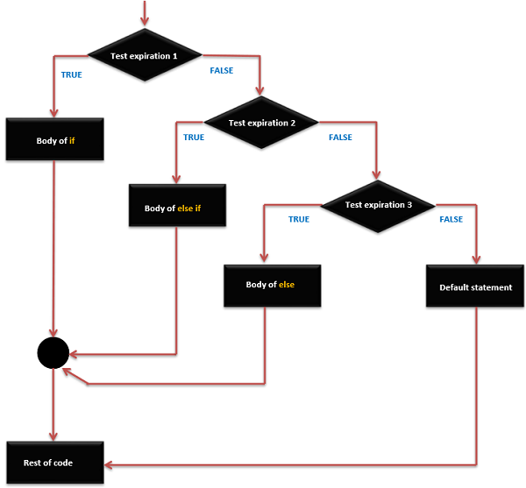

**The *if-else if-else* Statement Example**

*/* Global variable definition */*

*int A = 5 ;*

*int B = 9 ;*

*int C = 15;*

*Void setup () {*

*}*

*Void loop () {*

*/* check the boolean condition */*

*if (A > B) /* if condition is true then execute the following statement*/ {*

*A++;*

*}*

*/* check the boolean condition */*

*else if ((A == B )||( B < c) ) /* if condition is true then*

*execute the following statement*/ {*

*C = B* A;*

*}else*

*c++;*

*}*

**For further details refer to the Arduino programming reference guide**

<https://playground.arduino.cc/uploads/Main/arduino_notebook_v1-1.pdf>

Program

int numA = 5, numB = 7, numC = 9; // initialize the given variables

void setup() {

Serial.begin(9600); //initalize

Serial.println("Serial monitor setup done"); //initialization message

}

void loop() {

if(numA < numC){ //first condition - if A is greater than C

Serial.println("A is less than C"); //print A < C

Serial.print("A = "); // with value of A

Serial.println(numA);

Serial.print("C = "); //to compare to value C and print

Serial.println(numC);

++ numA;

} else if( (numB != numC) || (numB < numC)) { //is B is greater than C

Serial.println("B is less than C"); //print the evaluation in string

Serial.print("B = "); //with value of B

Serial.println(numB);

Serial.print("C = "); //and value of C

Serial.println(numC);

++ numB;

} else { //after all these cases

Serial.println("Neither A nor B is less than C"); //print that neither is greater

Serial.print("A = "); //with value of A

Serial.println(numA);

Serial.print("B = "); //B

Serial.println(numB);

Serial.print("C = "); //and C

Serial.println(numC);

}

}

Inputs/Outputs

Serial monitor setup done

A is less than C

A = 5

C = 9

A is less than C

A = 6

C = 9

A is less than C

A = 7

C = 9

A is less than C

A = 8

C = 9

B is less than C

B = 7

C = 9

B is less than C

B = 8

C = 9

Neither A nor B is less than C

A = 9

B = 9

C = 9

Neither A nor B is less than C

A = 9

B = 9

C = 9